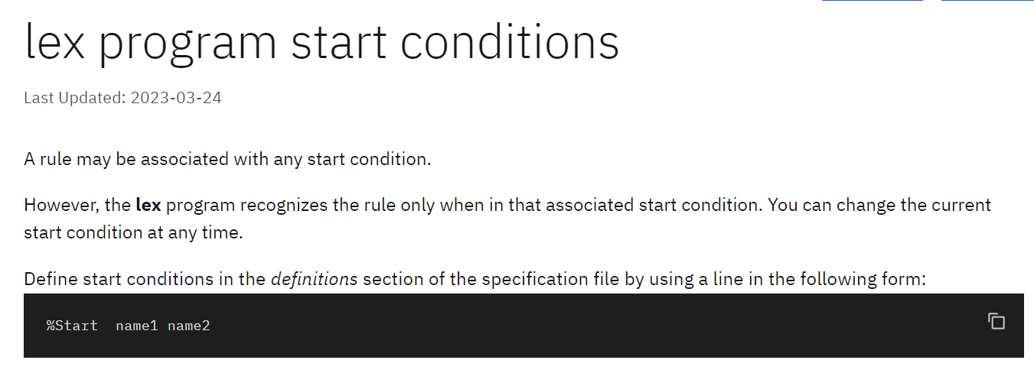

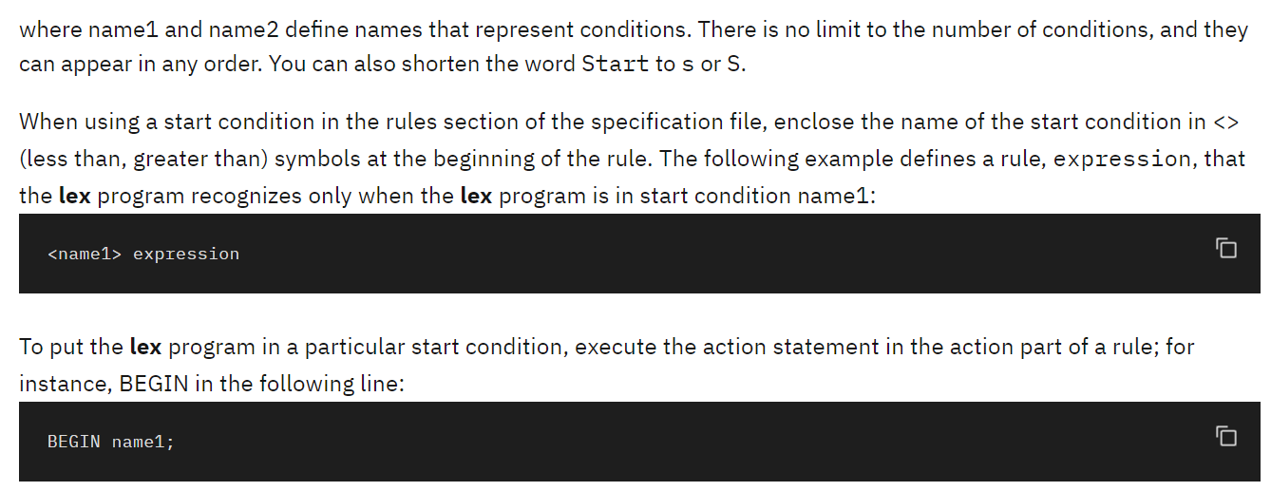

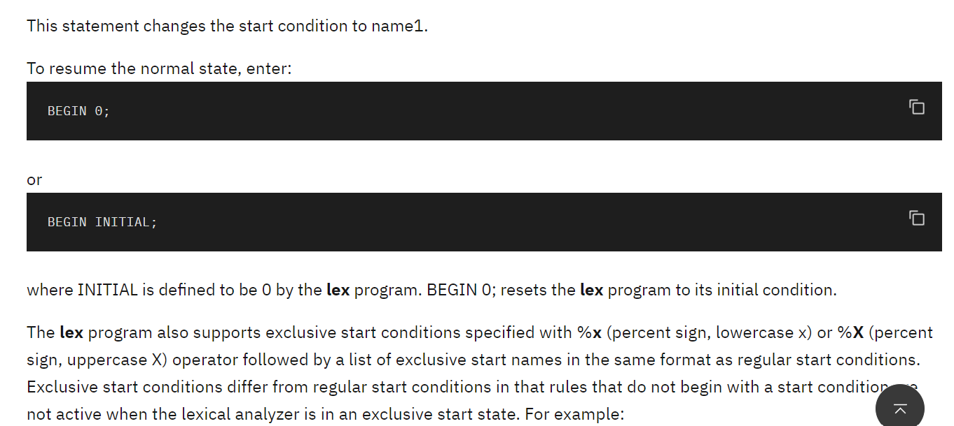

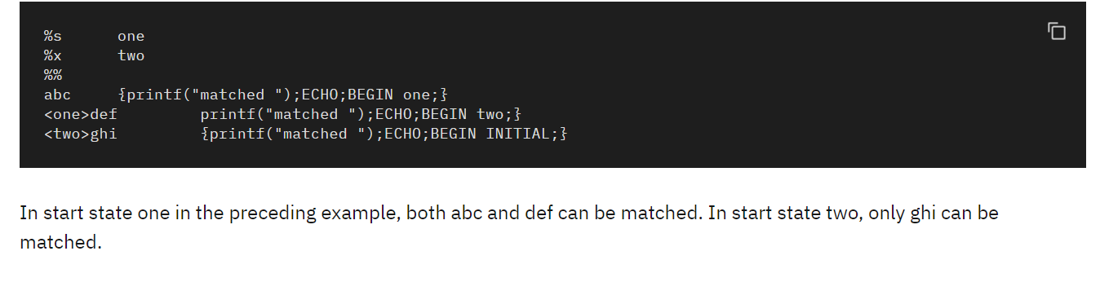

**6(a) Write a LEX program to eliminate *comment lines* in a *C* program and copy the resulting program into a separate file.**

%{

#include<stdio.h>

int comcount=0;

%}

%s COMMENT

%%

"/*" {BEGIN(COMMENT);}

<COMMENT>"*/" {BEGIN(0); comcount++;}

<COMMENT>. {;}

"//".* {; comcount++;}

.|\n {fprintf(yyout, "%s", yytext);}

%%

void main()

{

yyin = fopen("input.c","r");

yyout = fopen("output.c","w");

yylex();

printf("The no. of comment lines are:%d\n", comcount);

}

yywrap()

{

return 1;

}

[root@localhost ~]# lex testcom.l

[root@localhost ~]# cc lex.yy.c -ll

[root@localhost ~]# ./a.out

The no. of comment lines are:8

[root@localhost ~]# cat input.c

//this is the program to count the comment lines

#include<stdio.h>

void main()

{ /*Prolog

starts here*/

int a, b; //declaration statement

/*

*/

A= a +b; /* welcome to bit*/

/****************/

}// Epilog has encountered

/******End of the

Program

*********/

[root@localhost ~]# cat output.c

#include<stdio.h>

void main()

{

int a, b;

A= a +b;

}

OR

%{

#include<stdio.h>

int com=0;

%}

%%

"//".* {com++;}

"/*"([^*]|\*+[^*/])*\*+"/" {com++;}

.|\n {fprintf(yyout,"%s",yytext);}

%%

void main(int argc, char *argv[])

{

yyin=fopen(argv[1],"r");

yyout=fopen(argv[2],"w");

yylex();

printf("No of comment lines=%d\n",com);

}

OR

%{  
#include<stdio.h>  
int comcount=0;  
%}  
s "/"  
a "*"  
single \/\/.*  
multiline {s}{a}+([^*]|\n)*{a}+{s}  
%%  
{single} {;comcount++;}  
{multiline} {;comcount++;}  
.|\n fprintf(yyout, "%s", yytext);

%%  
void main()  
{  
yyin = fopen("inputcom.c", "r");  
yyout= fopen ("outputcom.c", "w");  
yylex();  
printf("The no of comment lines are:%d\n", comcount);  
}